Contents

Non Crystallographic Symmetry (NCS) refinement 1

Search terms for implementation in Phenix: 2

Read papers: 2

Tests 2

Work notes 2

Choosing origin 3

Choosing coordinate system 3

Parameters 3

Derivatives 4

Looking at gradient for one of the angles 5

Looking at gradient about a translation component 7

Other issues 7

Target and Gradient for transformation refinement 8

References 9

# Non Crystallographic Symmetry (NCS) refinement

Refinement of the rotation and translation operation used to produce the complete Asymmetric Unit (ASU) from a single NCS copy.

* Consider using least-squares, maximum likelihood and log likelihood target functions
* Check the linear optimization methods

Need to get a cost function and gradient (in relation to the refined parameters.

* Hypothesis: ${ H}_{\left\{R,T\right\}}=f(RX+T)$
* Parameters: $R,T$ Rotation and translation matrices.   
  (Need to maintain rotation characteristics during refinement and when shaking parameters for testing)
* Cost Function:
  + For least-squares (LS) use (Lunin & Skovoroda 1995):



Where



* For Maximum Likelihood estimation I need to work out the likelihood function, the probability of the transformation, given the coordinates. Get the probability from summing over all observation… need to create energy function.   
  Refinement of X-ray Crystal Structures  
  (Pannu & Read 1996)



* Consider refinement strategy if possible within the PHENIX machinery
* For high resolution data, consider ways to musk the part of the NCS copy that are not the same.
* Test refinement on PDB files that include all NCS copies, not only the 150 that do not.
* Check if there is some symmetry that specify what the transformation should be. For example, viruses biomolecule many times have a define symmetry, does this symmetry translate to analytical transformations for the ASU?

## Search terms for implementation in Phenix:

Target auto switch resolution

# Read papers:

(Afonine et al 2009), (Afonine et al 2005), (Lunin & Skovoroda 1995)

(Afonine & Urzhumtsev 2004)

[Note1](rigid_body_Euler.doc), Note2, [Refinement of X-ray Crystal Structures](../../../../../../Users/Youval/Downloads/brunger_adams_2012.pdf).

# Tests

* Model shape, number of NCS copies
* Shaking of R and T

# Work notes

Our “origin”, the center of rotation is not necessarily the center of mass or center of coordinates of the given NCS, perhaps it is so for the complete ASU. **It is important to know what is the reference coordinate system, since different rotation and translation will results from a different choice of system.**

I assume that the single NCS copy coordinates are the coordinates for which the Rotation and Translation operation are given to.

Let the coordinates of a single atom $i$, in the initial single NCS copy, in relation to the origin be: $x_{i}^{0}=\left(\begin{matrix}x_{i}^{0} \\ y_{i}^{0} \\ z_{i}^{0}\end{matrix}\right).$  
And for the $n^{'}th$ NCS copy $x_{i}^{n}=\left(\begin{matrix}x_{i}^{n} \\ y_{i}^{n} \\ z_{i}^{n}\end{matrix}\right)$ in a way that $x_{i}^{n}=R_{n}x_{i}^{0}+T_{n}$ Where $R_{n}$

And $T_{n}$ are the $n'th$ rotation matrix and translation vector.



## Choosing origin

The natural and the default choice can be the origin of the coordinate of the single NCS copy.

To allow origin change, write a function that convert the translation vectors according to the rotation matrices, when moving the origin, so that we will have 







## Choosing coordinate system

To avoid the issue caused in the case of $β=0, ±\frac{π}{2}$, when the rotation derivative becomes a function of $(α+β)$ and we can’t tell them apart, consider rotating the coordinate system around the $z$ axis, so ${\hat{x}}^{'}=\hat{y}$ and ${\hat{y}}^{'}=-\hat{x}$

## Parameters

Our data from the PDB file is $R,T$ not $(α,β,γ)$

So to get $(α,β,γ)$ from $R$ we can do the following:

Calculate the possible angles:



Choose $α_{1},β_{1}$ and calculate $R_{yz},R_{zz}$

If the signs of both the original $R_{yz},R_{zz}$ and the $R_{yz},R_{zz}$ calculated using the new angles are correct then either $(α_{1},β_{1})$ or $(α_{2},β_{2})$ are the correct pair

If not then either $(α_{1},β_{2})$ or $(α_{2},β_{1})$ are the correct pair

Now choose $γ_{1},β_{1}$ and calculate $R_{xx},R_{xy}$

If the signs of both original and calculated are correct then either $(γ_{1},β_{1})$ or $(γ_{2},β_{2})$ are the correct pair

If not then either $(γ_{1},β_{2})$ or $(γ_{2},β_{1})$ are the correct pair.

Now you can just choose angles that work

This will give as two possible solutions: $(α,β,γ)$ or $(π+α,π-β,π+γ)$, which mean that the rotation matrix is not unique in respect to the rotation angles. It does not matter to our purpose, as long as the angles produce the desire rotation matrix.

There is a unique cases of $β=\frac{π}{2},\frac{3π}{2}$, in those cases there is not ambiguity in $β$, $R_{xz}=1,-1$, and $\cos\left(β\right)=0$. In those cases the rotation matrix will become:





So there is not unique solution and we can just choose $α$ and $γ$ that obey equation.

A simple choice can be



**Maybe** we should consider a rotation of the coordinate system as described in choosing coordinate system

Check this http://www.soi.city.ac.uk/~sbbh653/publications/euler.pdf

# Derivatives

(Using Einstein summation notation)

Derivative of the cost (target) function  by transformation. The transformation contain information on Rotation and translation  , as described below in equation. The derivatives will be taken in relation to the rotation angles and the translation components as follows:



Where  is the atom index,  are the indices of the rotation matrix and.

The number of gradient derivatives will be  .

The  derivatives:











## Looking at gradient for one of the angles

Consider that



So



Where  is the  atom in the NCS being copied, and .  is a scale factor, to ensure the translation and the coordinate are of the same order of magnitude

Looking at the portion related to the angles in equation



Now to sum the derivative over all atoms using matrix multiplication, let  be:





Consider that our gradient by the coordinate,, is a matrix of size , and the our coordinates,  , is of the same order . ( is the number of atoms in a single NCS copy)

Note that D could also be the gradient of the restraints manager (of the regularization)

Define  such that



 is a  matrix of the form (The sum over all NCS atoms)



The Gradient of the cost (target) function, for each transformation, as written in equation, in relation to angle  is:



Where ,  components are at equations:, and

## Looking at gradient about a translation component



Note that . So we can define  as  matrix:



We get the three translation derivatives by



# Other issues

## It looks like minimization is getting stack in a some kind of a local minimum

### 100 cycles test result

Each test has 10 micros cycles and 60 max iterations. Shacking of angles and each translation component is done using random Gaussian generator.

#### Test 1

Shacking: shake_angles_sigma : 0.052, shake_translation_sigma : 1.5

R-work start mean: 0.4365 standard deviation: 0.0270

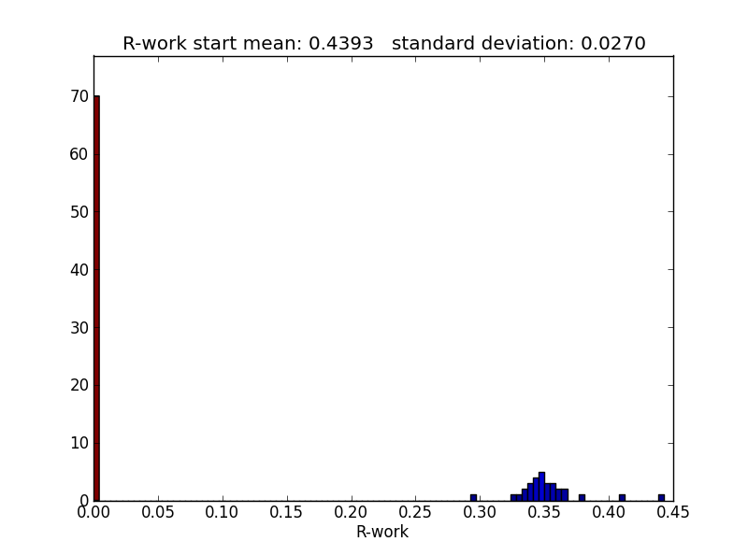

#### Test 2

Shacking: shake_angles_sigma : 0.032, shake_translation_sigma : 0

R-work start mean: 0.3407 standard deviation: 0.073

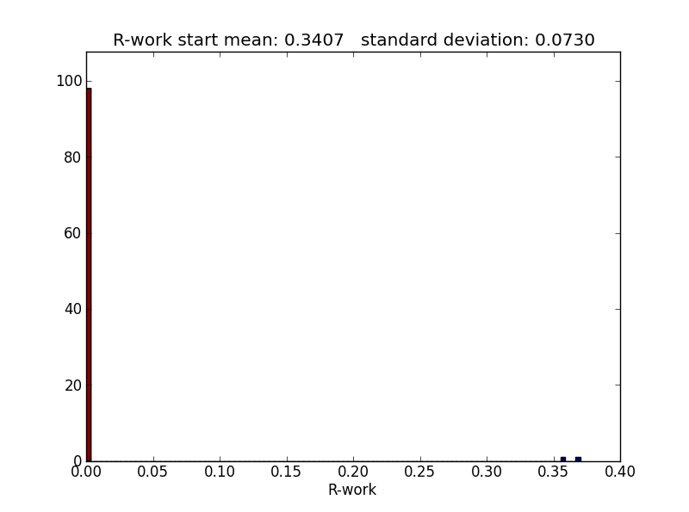

#### Test 3

Shacking: shake_angles_sigma : 0 , shake_translation_sigma : 1.5

R-work start mean: 0.430.1 standard deviation: 0.0305

#### Test 4

Shacking: shake_angles_sigma : 0.02, shake_translation_sigma : 0

R-work start mean: 0.1795 standard deviation: 0.0632

#### Test 5

Shacking: shake_angles_sigma : 0, shake_translation_sigma : 0.5

R-work start mean: 0.2757 standard deviation: 0.0693

#### Test 6

Shacking: shake_angles_sigma : 0.005, shake_translation_sigma : 0.1

R-work start mean: 0.4325 standard deviation: 0.0321  
Number of iteration that went down to R-wok = 0 : 0

Unclear to me yet, why it makes all the improvement at the first step and then stop improving

## Consider how to apply weights

Currently able to adjust weights on translations

## How to apply restraints manager

Want to include restrains manager to avoid potential clashes due to wrong transformations.

# Target and Gradient for transformation refinement

Input data (CIF file) and model (PDB)

Update model for Bulk-solvent and overall scaling

Get Miller arrays

Get weights

Average Bijvoet mates

Tidy up F-model xray structure  
Apply symmetry sites  
Update xray structure

Update xray structure and F-model

Get minimized angles and translations

Select strategy  
FFT or Direct  
ml, ls_wunit_k1 …  
(Max Likelihood or Least Squares)  
Use hydrogen or not

Get initial F-model

Get restraints manager

Get F-obs and F-free

Run minimizer

Set xray.set_scatterer_grad_flags   
with: transform = True

Set x to be the angles and translation parameters

Get F-model target fanctor

Call minimizer

# References

Afonine PV, Grosse-Kunstleve RW, Adams PD. 2005. A robust bulk-solvent correction and anisotropic scaling procedure. *Acta crystallographica. Section D, Biological crystallography* 61: 850-5

Afonine PV, Grosse-Kunstleve RW, Urzhumtsev A, Adams PD. 2009. Automatic multiple-zone rigid-body refinement with a large convergence radius. *J Appl Crystallogr* 42: 607-15

Afonine PV, Urzhumtsev A. 2004. On a fast calculation of structure factors at a subatomic resolution. *Acta Crystallogr A* 60: 19-32

Lunin VY, Skovoroda TP. 1995. R-Free Likelihood-Based Estimates of Errors for Phases Calculated from Atomic Models. *Acta Crystallogr A* 51: 880-87

Pannu NS, Read RJ. 1996. Improved structure refinement through maximum likelihood. *Acta Crystallogr A* 52: 659-68